**BANGLADESH UNIVERSITY OF BUSINESS AND TECHNOLOGY**

**(BUBT)**



**Lab Report**

Course Code : CSE 324

Course Title : Compiler Design Lab

Date of Submission: February 18, 2024

Submitted By

Name : Aktaruzzaman

ID : 21222203031

Intake : 41

Section : 1

Submitted To

**Ms. Adeeba Anis**

Lecturer

Department of Computer Science & Engineering

Bangladesh University of Business and Technology (BUBT)

**Experiment No: 0**5

**Experiment Name:** Recognizing Strings under 'xy^*z' and 'ya^+ b'

**Problem Structure**

The objective of this experiment is to develop a C++ program that recognizes strings based on specific patterns: 'xy^*z' and 'ya^+ b'. The pattern 'xy^*z' means that the string should contain 'xz' or 'xy…z' consecutively, while 'ya^+ b' means that the string should contain 'yab' consecutively. The program should prompt the user to input a string, analyze it based on these patterns, and provide appropriate output.

**Procedure**

* 1. Define helper functions to remove consecutive characters from a string and to check if specific substrings are present.
* 2. Prompt the user to input a string.
* 3. Remove consecutive characters from the input string using the helper function.
* 4. Check if the input string contains 'xz' or 'xyz' to recognize the pattern 'xy^*'.
* 5. Check if the input string contains 'yab' to recognize the pattern 'ya^+ b'.
* 6. Display appropriate output based on the recognized patterns or if the string is not recognized.

**Code:**

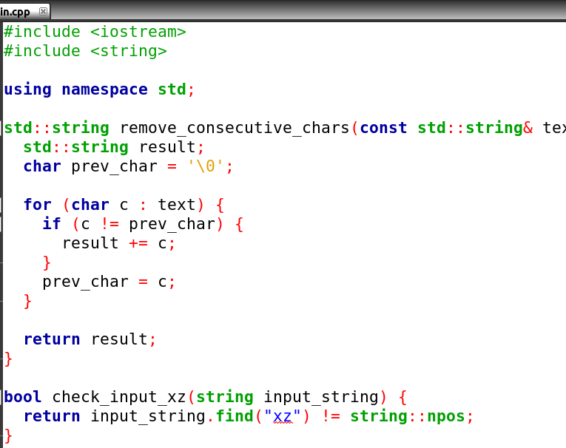

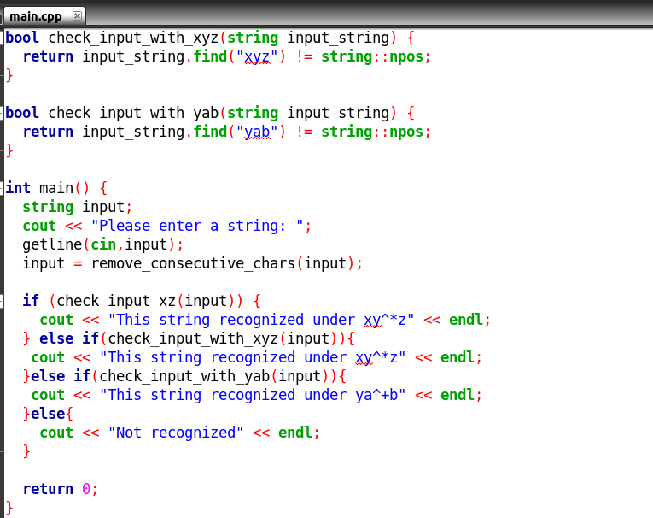

**Input and Output**

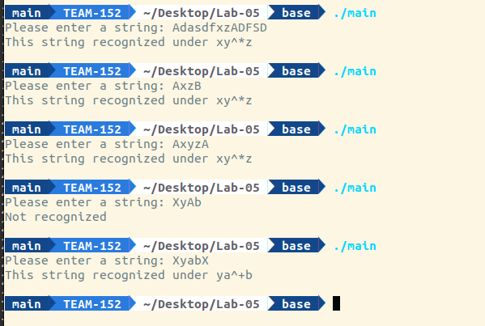

**Conclusion**

The program successfully identifies strings based on the specified patterns 'xy^*' and 'ya^+ b'. It demonstrates the usage of string manipulation and pattern recognition techniques in C++.